Below are a few housing options recommended by our office for you to consider (in numerical order) while here on rotation. Also listed below are transportation options for your convenience
1st choice
Highland Montgomery Apartments, Highland Park, NJ (Good Location)
Proximity to RWJ Hospital: Close by
9 minutes by car
26 minutes walking distance
https://maps.app.goo.gl/bi8CQbMJcGrnGmbB6
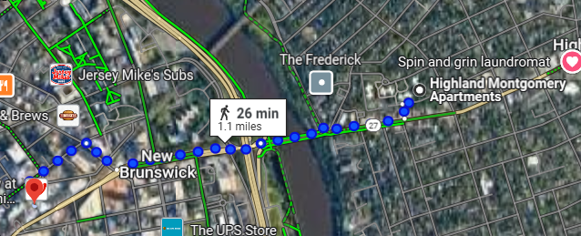

Monthly Rates: Reasonable
Studio
$1,920 – $1,970
1-Bedroom, 1-Bath
$2,340
2-Bedroom, 1-Bath
$2,610 – $2,670
(Contact Rutgers Housing https://oncampus.rutgers.edu/)

2nd choice
The Vue – Located on Somerset St New Brunswick, NJ
Proximity to RWJ Hospital: great location extremely close
5-minute walk to hospital
https://maps.app.goo.gl/ifQf4fmocejCgRH77
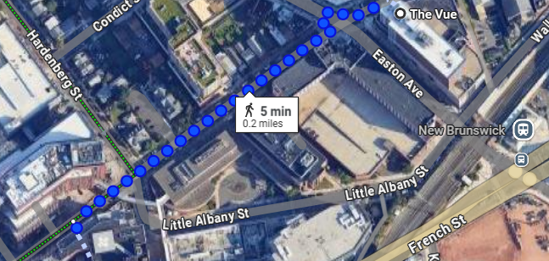

Monthly Rates are pricey due to the immediate proximity to the hospital and New Brunswick’s business district
1-Bedroom, 1-Bath
$2,990
2-Bedroom, 2-Bath
$3,680
(Contact Rutgers Housing https://oncampus.rutgers.edu/)

3rd choice:
Johnson Apartments Piscataway, NJ located on Rutgers Busch Campus. (between late May and June the campus bus does not run as frequently so we do not recommend it during those months)
Proximity to RWJ Hospital: Nearby
11 minutes by car
½ hour by campus bus
1+ hr. walking distance
https://maps.app.goo.gl/Um5qTQTGBvpr5gEb8
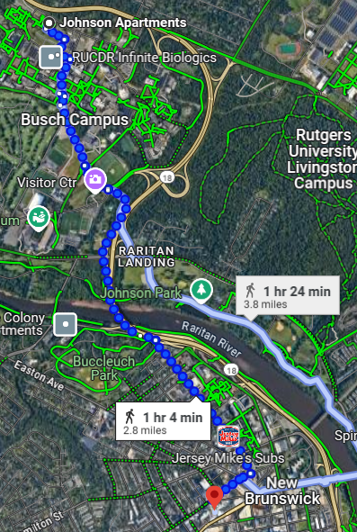

Monthly Rates: Please note the rates are standard and applicable given the Rutgers Busch Campus location.
2-Bedroom, 1-Bath
$2,260
Updated
2-Bedroom, 1-Bath
$2,360
ADA
1 Bedroom, 1-Bath
$2,090
(Limited availability and special rules apply)
(Contact Rutgers Housing https://oncampus.rutgers.edu/)

Transportation options (available for airport pickup and drop off)
If you require help with finding transportation, we can assist you with it
- New Jersey Transit (NJT) https://www.njtransit.com/abc_northeast_corridor
- Uber www.uber.com – download app
- Lyft www.lyft.com – download app
- Rutgers Campus Bus
https://ipo.rutgers.edu/transportation
Campus bus tracker (live)
https://rutgers.passiogo.com/

Additional Housing Options – The Office of Global Health and Robert Wood Johnson Medical School do not endorse these programs but provide this list as a service to international students.

Airbnb
https://www.airbnb.com/new-jersey-united-states/stays

Premier Properties Of New Brunswick
191 Hamilton Street, New Brunswick, NJ
732.246.7048
https://www.premierpropertiesofnewbrunswick.com/property/191-hamilton-street
Community Facebook groups:
Rutgers Indian Graduate Student Association (RIGSA)
Rutgers (RU) Housing, Sublets & Roommates

